**SRM INSTITUTE OF SCIENCE AND TECHNOLOGY**

**DEPT. OF COMPUTER SCIENCE AND ENGINEERING(Data Science)**

**Sub code & Name: 18CSS101J – PROGRAMMING FOR PROBLEM SOLVING**

|  |  |
| --- | --- |
| **TITLE:** | **CHATBOT FOR ORDERING FOOD** |
| **NAME OF THE CANDIDATES:** | **Vipasha Ratwani**  **Charugundla NV Krishna Parvani**  **Prathosh M. Vishweshwar** |
| **REGISTERATION NUMBER:** | **RA2111056010030**  **RA2111056010017**  **RA2111056010016** |
| **DATE:** | **24/06/2022** |

**MARK SPLIT UP**

|  |  |  |  |
| --- | --- | --- | --- |
| **S.NO** | **DESCRIPTION** | **MAXIMUM MARK** | **MARKS OBTAINED** |
| **1** | **CHATBOT FOR ORDERING FOOD:** | **10** |  |
| **2** | **Demonstration and viva:** | **10** |  |
| **3** | **Uploading in Git hub:** | **5** |  |
|  | **TOTAL:** | **25** |  |

**Staff Signature with date**

**CHATBOT FOR ORDERING FOOD:**



# DESCRIPTION OF THE PROJECT:

**At the most basic level, a chatbot is a computer program that simulates and processes human conversation (either written or spoken), allowing humans to interact with digital devices as if they were communicating with a real person. User communicate with chatbot via the chat interface or by voice, like how they talk to real person. Chatbots interpret and process user's words or phrases and give an instant pre-set answer.**

**. Food ordering chat bot**

**. Ordering through text**

**. Can be converted to voice**

**. Configuration text is through files**

## ALGORITHM:

STEP 1: Start

STEP 2: Declare the following functions:

. type

. category

. submenu

. option

. total

. soption

STEP 3: Declare the following variables

. username

. welcome

. category

. meals

. juice

. deserts

. mobile

. support

STEP 4: Display "CHATBOT FOR ORDERING FOOD"

STEP 5: If(decision=0)

. Display "bye" to exit

STEP 6: If(decision=1)

. Display "hello" to start

STEP 7: If(decision=2) and if 1 is chosen

.Display" welcome"

1.order

STEP 8: If(decision=3) and the chosen number is 1

.Display "category"

STEP 9: If(decision=4) and the category 1 is chosen

STEP 10: If(decision=5) and the submenu 2 is chosen

STEP 11: If(decision=6) and the submenu 3 is chosen

STEP 12: Display "confirm order”

STEP 13: If "yes" is chosen

. Display "Your order total"

STEP 14: If "no" is chosen

. Display "Add more items"

If (decision =3) order is decided take category and go to step 7 and repeat the process.

STEP 15: If "cancel" is chosen, it restarts from step 5.

STEP 16: If "bye" is chosen, the process exit.

STEP 17: If "2" is chosen (from STEP 7)

. Display "support"

STEP 18: In support if "1" is chosen

. Display "Please Contact support:999-999-999 Thank you"

STEP 19: If "2" is chosen

. Display "Please Contact:100-110-111 Thank you"

STEP 20: End

## PSEUDOCODE:

1.Start

2.Show initial screen

3.Show welcome message

4.ask user to enter order or support

5.if order choose category or submenu

6.if category meals choose sub category

7.if category juice choose sub category

8.if category deserts choose sub category

9.if support display option 1 is order support 2 is refund/cancel

10.options to user to add more, exit or cancel order

11.if confirm order is yes show total and exit

12.if bye exist

13.if order more go to category

14.if cancel order – go to welcome message and start over

15.end

## FLOWCHART

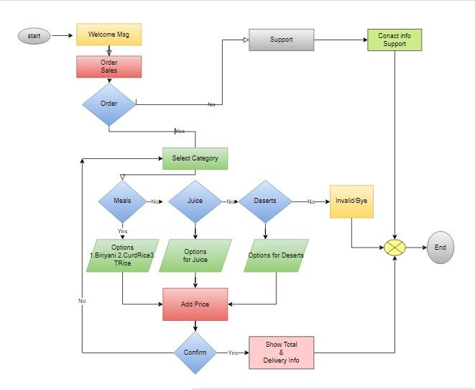

## CODE

#include <stdio.h>

#include <string.h>

int type,catg,submenu,option;

int total=0;

char soption[50];

/*********************

decoding the option to text/string form

input : option in int form

output : string name in global array soption[]

*******************/

void decode(int option)

{

if (option==1) {

strcpy(soption,": Veg Biriyani Rs 150/-");

total = total + 150;

}

if (option==2) {

strcpy(soption,": Tomato Rice Rs 90/- ");

total = total + 90;

}

if (option==3) {

strcpy(soption,": Curd Rice Rs 50/-");

total =total +50;

}

if (option==4) {

strcpy(soption,": Fruitninja Rs 20/-");

total += 20;

}

if (option==5) {

strcpy(soption,": Tornado Rs 25/-");

total += 25;

}

if (option==6) {

total+=30;

strcpy(soption,": Lightning Bolt Rs 30/- ");

}

if (option==7) {

total += 100;

strcpy(soption,": Cake Rs 100/-");

}

if (option==8) {

total += 40;

strcpy(soption,": Ice Cream Rs 40/-");

}

}

/*******************

To add line based on supplied character as argument

input : function argument as character

output : 80 characters in one row

*******************/

void beautyline(char *c){

printf("\n");

for (int i=0;i< 80; i++) {

printf("%c",*c);

}

printf("\n");

}

/*********************

file : srmeats2.c

input : config.txt

*********************/

int main() {

char useranswer[100] ="default" ;

char welcome[100] ;

char category[100] ;

char meals[100] ;

char juice[200];

char deserts[100];

char support[100];

char mobile[20];

char filename[20] = "config.txt";

FILE *fp; int i;

char line [200];

fp = fopen(filename, "r");

if (fp == NULL)

{

printf("Error: could not open file %s", filename);

return 1;

}

if (fgets(line,sizeof (line),fp)!= NULL){

strcpy(welcome,line) ;

// printf("%s\n", welcome);

}

if (fgets(line,sizeof (line),fp)!= NULL){

strcpy(category, line) ;

// printf("%s\n", category);

}

if (fgets(line,sizeof (line),fp)!= NULL){

strcpy(meals,line) ;

// printf("%s\n", meals);

}

if (fgets(line,sizeof (line),fp)!= NULL){

strcpy(juice,line) ;

// printf("%s\n", juice);

}

if (fgets(line,sizeof (line),fp)!= NULL){

strcpy(deserts,line) ;

// printf("%s\n", deserts);

}

if (fgets(line,sizeof (line),fp)!= NULL){

strcpy(support,line) ;

// printf("%s\n", deserts);

}

fclose(fp);

// readfromfile();

int decision=0;

while (strcmp(useranswer, "bye") !=0) {

if (decision ==0 ) { //get hello string

beautyline("*");

printf(" CHATBOT FOR ORDERING FOOD\n");

scanf("%s", useranswer);

}

if (decision==0 && (strcmp(useranswer, "hello") ==0)){

decision=1;

}

// printf("%s\n",response2);

if (decision ==1){ //welcome

printf("%s\n", welcome);

decision =2; //order or support

scanf("%s", useranswer);

printf("you chosen : %s\n", useranswer);

if (strcmp(useranswer, "1") ==0)

decision =3; //order

}

if (decision==3 || strcmp(useranswer, "1") ==0){ //order

//printf("you chosen : %s\n", useranswer);

//type=1;

decision=3; //category

if (decision==3) {

printf("%s\n",category);

scanf("%s", useranswer);

}

if (strcmp(useranswer, "1") ==0){// category meals

printf("you chosen : %s\n", useranswer);

decision=4;

if (decision==4) {

printf("%s\n", meals);

scanf("%d", &submenu);

if (submenu <1 || submenu > 3 ) {

printf ("invalid\n"); decision=4; continue;

}

option = submenu;

}

}//meals

else if (strcmp(useranswer, "2") ==0){ //juice

printf("you chosen : %s\n", useranswer);

//catg=2;

decision=5;

if (decision ==5 ) {

printf("%s\n", juice);

scanf("%d", &submenu);

printf("you chosen : %d\n", submenu);

}

if (submenu <1 || submenu > 3 ) {

printf ("invalid\n");

decision=5;

continue;

}

option = submenu+3;

} //juice

else if (strcmp(useranswer, "3") ==0){ //desert

printf("you chosen : %s\n", useranswer);

//catg=3;

decision=6;

if (decision==6) {

printf("%s\n", deserts);

scanf("%d", &submenu);

}

if (submenu <1 || submenu > 2 ) {

printf ("invalid\n"); decision=6; continue;

}

option = submenu+6;

} //deserts

decode(option);

printf("Confirm Order %s . \nPlease type \n yes to confirm order and exit. \n no to add more items. \n cancel to cancel and restart. \n bye to exit.\n ",soption);

scanf("%s",useranswer);

if (strcmp(useranswer, "yes") ==0) {

beautyline("*");

printf("Your order total : %d \n ",total);

printf("\nplease enter mobile number\n");

scanf("%s",mobile);

printf("\nConfirmed order will be delivered soon!\n Thank you!\n");

beautyline("*");

scanf("%s",mobile);

return 1;

}

else if (strcmp(useranswer, "no") ==0) {

printf(" Add more items-\n");

decision =3; //order is decided take category

// strcpy(useranswer, "1");

continue;

}

else if (strcmp(useranswer, "cancel")==0){

decision =0; continue;

}

else if (strcmp(useranswer, "bye") ==0) {

return 1;

}

}//order

else if (strcmp(useranswer, "2") ==0) { //support

printf(" %s\n", support);

scanf("%s", useranswer);

//type=2;

if (strcmp(useranswer, "1") ==0)

printf("Please Contact support: 999-999-999\nThank you");

if (strcmp(useranswer, "2") ==0)

printf ("please contact: 100-110-111\nThank you");

return 1;

}

}

return 1;

}

## OUTPUT

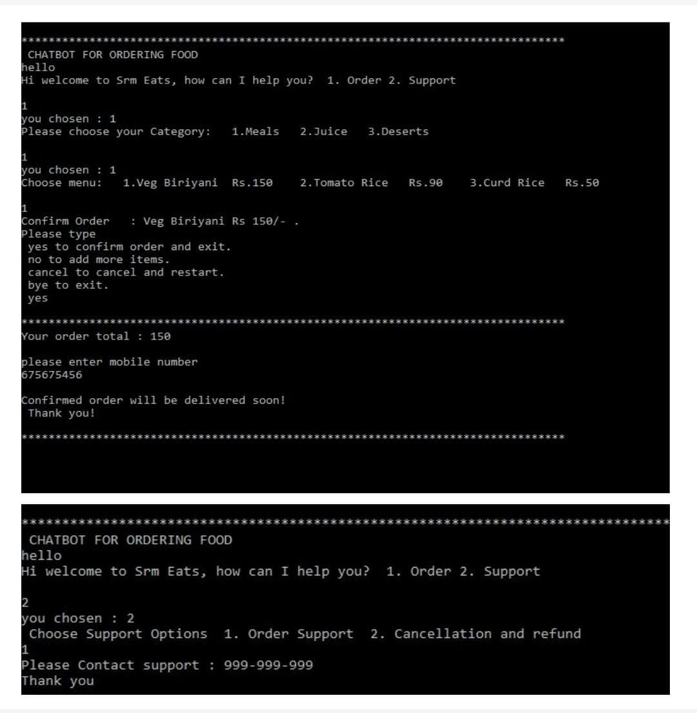

**THANK YOU**